REDEEMED · redeemedblog.com
THE SWORD BIBLE STUDY METHOD
Study the Scriptures · Hebrews 4:12

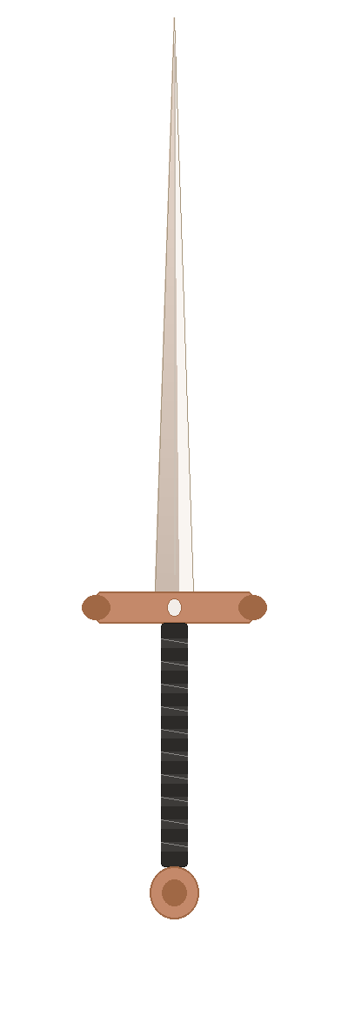 |  | In Hebrews 4:12, Scripture describes the Word of God as a living, active sword — sharp enough to cut to the very core of who we are. That image gives us a powerful and memorable way to approach every passage we read. Picture a sword held upright: the blade pointing to heaven, the handle pointing to the earth, and the hilt connecting the two. Each part of the sword represents one essential question.  THE BLADE (pointing upward toward God)  “What do I learn about God, Jesus, or the Holy Spirit?”  THE HANDLE (pointing downward toward people)  “What do I learn about people?”  This includes what you observe about specific characters in the passage as well as what the text reveals about humanity in general.  THE HILT (connecting the two)  “How is God calling me to respond?”  The hilt connects blade and handle — just as this question connects what you’ve learned about God and people to your own life.  These three questions are simple to remember and powerful to use. They can completely transform what you take away from any passage of Scripture.
  HEBREWS 4:12 (ESV)
  “For the word of God is living and active, sharper than any two-edged sword, piercing to the division of soul and of spirit, of joints and of marrow, and discerning the thoughts and intentions of the heart.”
  Note: Prayer is at the heart of Scripture reading. Begin your study by thanking God for His Word and asking Him to reveal Himself to you. Pray throughout — when you’re confused, when you’re moved, and when you finish. Let what you read fuel how you talk to Him.
  TEACHING TIP
  If you are teaching the Sword Method to a group, consider having participants stand and imagine their body is a sword. Have them repeat each question while acting out the matching part — arms raised to the sky = blade = the question about God; arms at your sides = handle = the question about people; arms on hips = hilt = the question about how God is calling you to respond.

REDEEMED · redeemedblog.com
THE SWORD BIBLE STUDY METHOD
Study the Scriptures — Worksheet

Passage: ____________________________________________________

THE BLADE
What do I learn about God, Jesus, or the Holy Spirit?

THE HANDLE
What do I learn about people?

THE HILT
How is God calling me to respond?

Note: Prayer is at the heart of Scripture reading. Begin your study by thanking God for His Word and asking Him to reveal Himself to you. Pray throughout — when you’re confused, when you’re moved, and when you finish. Let what you read fuel how you talk to Him.

